Project Development Phase
Model Performance Test

Date | 01 September 2026
Team ID | Individual Project
Project Name | Software Installation Request Automation in ServiceNow Using Service Catalog and Workflows
Maximum Marks

Model Performance Testing:
Project team shall fill the following information in model performance testing template.
S.No. | Parameter | Screenshot / Values
1. | Data Rendered | Service Catalog software installation requests, request items, and catalog tasks are handled through the sc_request, sc_req_item, and sc_task tables.  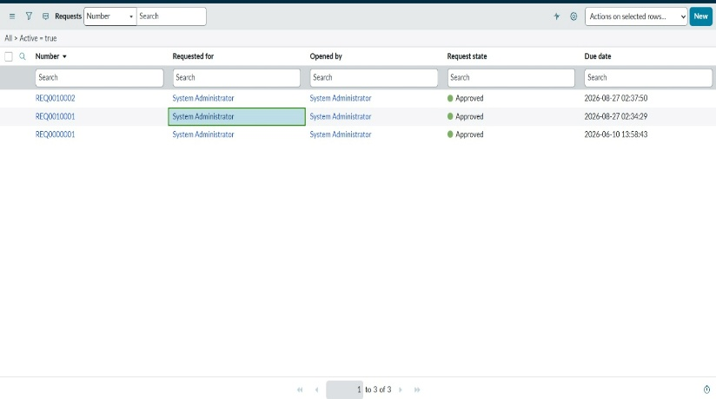
2. | Data Preprocessing | Software Name, Version Required, License Justification, and Urgency are captured as catalog variables. Urgency options: Normal, High, Critical.  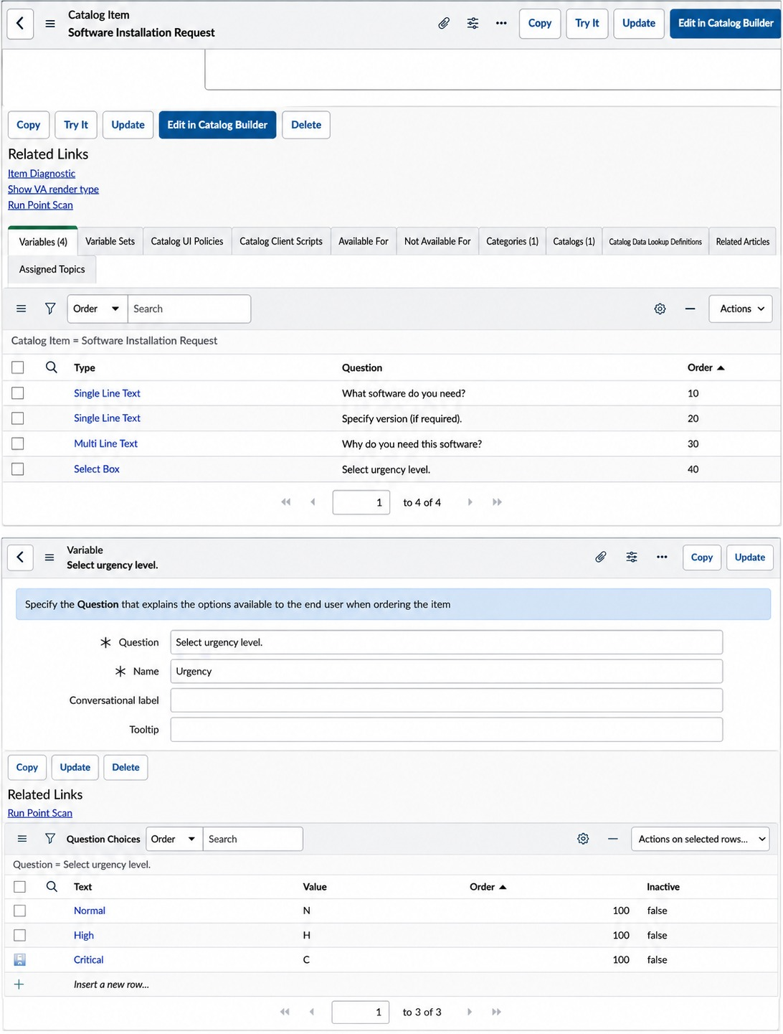
3. | Utilization of Data Filters | Urgency: Normal, High, Critical; Task State: Open, Work in Progress, Completed.  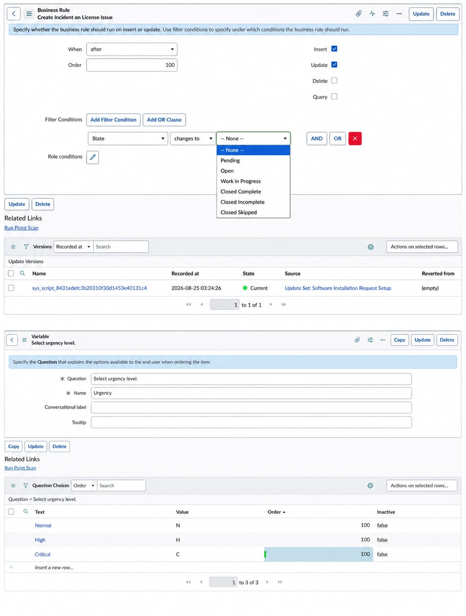
4. | DAX Queries Used | No DAX queries are specified in the supplied project reference document  ______________________________________________________________________________________________________________________________________________________________________________________________________________________________________________________________________________________________________________________________________________________________________________________________________________________________________________________________________________________________________________________________________________________________________________________________________________________________________________________________________________________________________________________________________________________________________________________________________________________________________________________________________________________________________________________________________________________________________________________________________________________________________________________________________________________________________________________________________________________________________________________________________________________________________________________________________________________________________________________________________________________________________________________________________________________________________________________________________________________________________________________________________________________________________________________________________________________________
5. | Dashboard design | No of Visualizations / Graphs - Not specified in the supplied project reference document.  ______________________________________________________________________________________________________________________________________________________________________________________________________________________________________________________________________________________________________________________________________________________________________________________________________________________________________________________________________________________________________________________________________________________________________________________________________________________________________________________________________________________________________________________________________________________________________________________________________________________________________________________________________________________________________________________________________________________________________________________________________________________________________________________________________________________________________________________________________________________________________________________________________________________________________________________________________________________________________________________________________________________________________________________________________
6 | Report Design | No of Visualizations / Graphs - Not specified in the supplied project reference document.  __________________________________________________________________________________________________________________________________________________________________________________________________________________________________________________________________________________________________________________________________________________________________________________________________________________________________________________________________________________________________________________________________________________________________________________________________________________________________________________________________________________________________________________________________________________________________________________________________________________________________________________________________________________________________________________________________________________________________________________________________________________________________________________________________________________________________________________________________________________________________________________________________________________________________________________________________________________________________________________________________________________________________________________________________________________________________________________________________________________________________________________  __________________________________________________________________________________________________________________________________________________________________

